Datiz and the Whale Shark
Suggested Key Stage: KS2
Pre-reading Stage
- Scan the QR code and watch the video clip. Fill in the blanks to complete the description of whale sharks.
Whale sharks are gentle giants of the ocean. They have ______________ spots and their heads are wide and _____________. They are not mammals. They are the largest shark and _____________ in the world. They can grow to ______ metres long. Although they are huge, they eat plankton, krill and small fish. They eat by ____________ eating. They swim thousands of miles each year to __________ waters.

They are an endangered species because fishermen catch them for _______________, or they get tangled in fishing ______________ or struck by boats. Increasingly laws are made to __________ them and ban fishing for them, because they are a _____________ attraction and people come from all over the ____________ to where they are known to be found or to aquariums keeping them.

- Some fishermen use destructive methods such as blast fishing to catch more fish. What is “blast fishing”? Read the part “Glossary” on p.23 of the reader “Datiz and the Whale Shark”. Find out its meaning by filling in the blanks below.

Blast fishing means people use ______________ such as bombs to kill many fish at one time.
- The story is about people using blast fishing to catch fish. How does blast fishing affect marine life? Scan the QR code and watch the video clip. Tick its negative impact in the boxes provided below.
- Many fish species which are of no use to the fishermen are killed.
- Most target fish species sink to the seabed where the fishermen can’t reach.
- A lot of coral reefs are demolished, which takes around a century to recover.
- All of the above.

While-reading Stage
Complete the story map below by filling in the blanks with the key words taken from the text.
(a) Characters  (Who were the characters?)  The main characters were ____________ and the (talking) ____________ _____________ (Splash). | 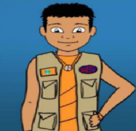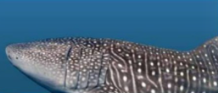
(b) Setting  (Where did the story take place?)  The story took place on _______________ Island. | 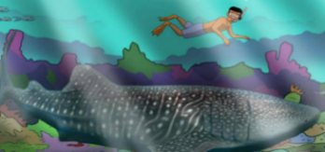
(c) Problem  (What happened in the sea?)  When ____________ arrived, ___________ dived into the water and found his friend _____________.They suddenly heard a loud BOOM, and saw a mess of bubbles, ____________coral and ___________ fish floating to the surface. | 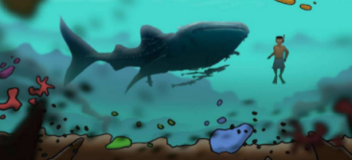
(Before the people learned about the bad side of the new fishing method, what did they care about?)  Before the people learned about the bad side of ___________ ______________, they only cared about the amount of fish caught. | 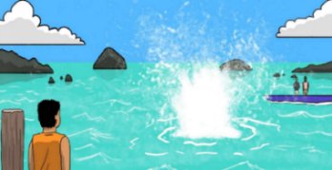
“We, merchants, can sell __________ ________ to chefs!”
“We, fishermen, can catch _________ ________ to sell at the market!”
“We, chefs, can buy fish ___________ and sell meals at ___________ prices!”
“We, customers, can pay for meals at ___________ prices!”

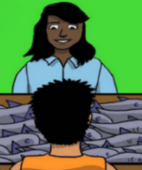
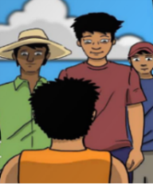
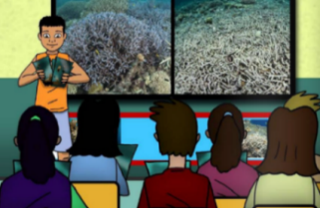
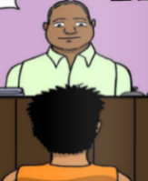
“We, fishermen, feel __________ to have no more coral reefs and fish!”
“We, chefs, will not ___________ fish that are caught using fish bombs because _____________ want us to cook the sustainably caught fish”.
“We, merchants, won’t ___________ fish that are caught with fish bombs! We must tell the _____________.”
“We, customers, only want to have fish that are caught in a _______________way!”

(d) Solution
(What did the character do? What did the people want to do?)
___________ conducted talks and showed the people pictures of the terrible _____________ of blast fishing. They wanted to _____________ the reefs and the fish after learning about its bad side.
(e) Moral/ Message
1. If we protect our marine life from further damage, they will _____________.
2. To protect the environment, it is important to educate all the _____________.
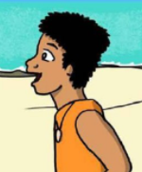

Datiz and the Whale Shark

Post-reading Stage
- Using linking words to express contrasting ideas
Even though | the chef has plenty of fish for his customers now, | it is not sustainable.
Although | the merchant has many fish to sell at low price now, | soon she will have none.
the original idea:
People only care about the amount of fish caught now / the price of fish sold now.
a different idea:
There will be no more fish in the future.
linking words/ conjunctions

- Underline the sentence with contrasting ideas from the following page:
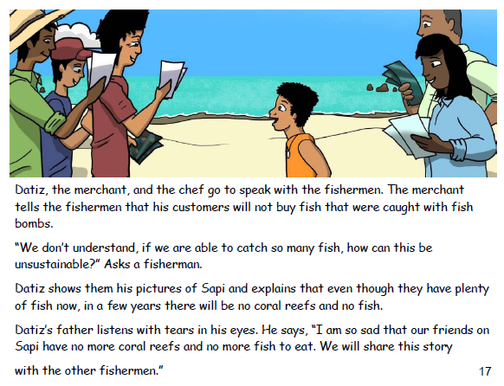
- It is important to live a green life to reduce waste and protect the environment. Write two sentences to explain to the children why they need to live a green life and how to protect the environment.
e.g. Although it is comfortable to turn on the air-conditioner, it will cause global warming.
1)
2)

- Using conditional sentences to express cause-effect relationship
Effect:
Main clause to explain the result
If clause to explain the Cause:

If people continue blast fishing, | soon there will be no more coral reefs and no more fish for people to eat.
If we protect the coral reefs from further damage, | over time they will recover.

- Underline the sentence with cause-effect relationship from the following page:
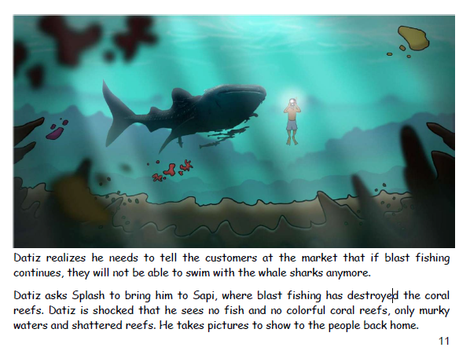

- Many children want to keep a pet. Write two sentences to give advice to the children who want to keep a pet.
e.g. If you do not think carefully before keeping a pet, it will be a big trouble to you and to your pet.
1)
2)

- You are a young ambassador. You are concerned about the endangered animals and care for the pets. A reporter is interviewing you about animal protection. Answer the questions.

- An interview about Endangered Animals
1) | Reporter: Why is it important to protect the endangered animals? | You:
2) | Reporter: How can we protect the endangered animals? | You:
3) | Reporter: What can students do to protect the environment? | You:

- An interview about Pet Care
1) | Reporter: Why is it good to keep a pet? | You:
2) | Reporter: Can you give some advice to your friends if they want to keep a pet? | You:
3) | Reporter: How can we keep a healthy pet dog? | You:

Pre-writing
A diary entry from the perspective of the whale shark
- Splash, the talking whale shark, had a terrible day and she wrote a diary entry to record what she experienced and thought. Read the diary below.
Monday, 20th March 20xx

It’s March again! I couldn’t wait to see my good human friend, Datiz. Datiz loves diving and we met each other in the ocean. When we first met, I thought Datiz would be scared of me because I am the largest animal in the ocean, and even in the world! I am as big as a school bus! Later, Datiz knew that I am very gentle and I only love eating plankton, so he felt relieved to make friends with me.

This morning, when Datiz and I were swimming around the coral reefs and talking about the adventures we had since we last saw each other, we heard a loud BOOM suddenly! We then saw a mess of bubbles, broken coral and dead fish floating on the surface. We were so scared! I told Datiz to hop on my back and I tried my best to swim as fast as I could. Luckily, we could escape from it.

This recalled my heartbreaking memory in Sapi. Sapi was a beautiful island, which was full of fish and colourful coral reefs. However, the fishermen there were greedy. They wanted to catch more fish, so they threw fish bombs into the water. Blast fishing is a very cruel way to catch fish. One of my best friends was hit by the fish bomb. He was seriously injured and died at last. I couldn’t stop crying whenever I thought of the suffering of my friend. Blast fishing also destroys the coral reefs. Coral reefs are important to many sea creatures as they provide the sea creatures with food and places to live. Once they are damaged, it takes decades to recover. I hope Sapi can resume its beauty soon.

If people in Mantanani keep catching fish in this way, I will not go there anymore as all the sea creatures and coral reefs will soon die and there will not be any food for me. Every human being, even a kid, can do something to help the sea creatures and the environment! He/She can ask his/her family to stop buying fish that are caught with fish bombs. If everyone is doing that, we can make a difference. I hope every human being can take action now!
2. Underline the key words and important information in each paragraph.
Content and Organisation of the Diary Entry
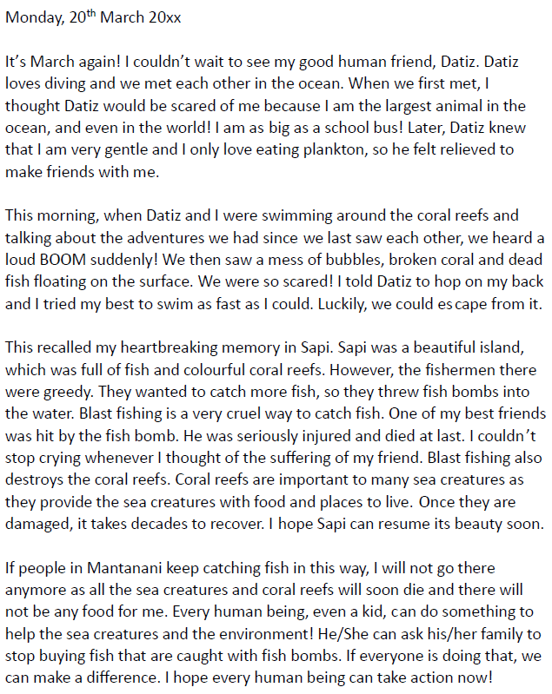
The ________ is at the top of the diary entry.
Paragraphs 2 & 3:
- How did the people catch fish?
- Why was this fish catching method cruel?
- How did it affect the environment?
Paragraph 4:
- What can people do to help the whale shark and other sea creatures?
Paragraph 1:
- Where can you find the whale shark?
- How does it look like?
- What is its favourite food?
- Underline one example of each feature from the diary entry using different colours.
Grammar Items and Language Used in the Diary Entry
Include your ________, e.g. I hope Sapi can resume its beauty soon.
Don’t forget to:
- use a friendly tone
- describe the events in the order they happen

Include your _________ and thoughts, e.g. We were so scared!
Use personal pronouns, e.g. _____ and _____.
Use the simple ____________ tense to state the fact, e.g. I am as big as a school bus!
Use the simple ____________ tense to write about things that happened, e.g. I couldn’t wait to see my good human friend, Datiz.
Writing a diary entry

- Information search

In the story, many sea animals were brutally killed by blast fishing. In fact, different kinds of animals (e.g. pets, farm animals, wild animals) are treated cruelly by human beings. For example, some pet dogs suffer a lot because of the selfish and irresponsible acts of their owners.
Let’s do a research on cruel practices to pet dogs. Study the information on the website of People for the Ethical Treatment of Animals (PETA) and complete the table below.

Cruel practices to pet dogs | Reasons
- Chaining dogs _______________________  ___________________________________  - Keeping them _______________________ | - Dogs are _____________ animals who need and deserve ________________________, ________________________________ and _______________________________.  - These practices prevent them from ____________________________________  ____________________________________ and is just a way for ____________________  ____________________________________  ____________________________________  until they get around to taking care of them properly.
- Cruel, unnecessary ___________________ that is performed on dogs, e.g. __________________________________  ___________________________________ | - Human _____________ or ______________  - ________________________________ and _____________________________ to dogs  - They are _____________ in many countries, but they remain legal in the _____________
- _____________ of animals | - It may cause animal ___________________ crisis.  - The consequences are _____________ and often ______________________________.

- Ideas for shared writing

Imagine that you were a pet dog living with your owner, Amy, in an apartment. Amy has to work all day. For the sake of convenience, Amy puts you in a cage before she goes to work early in the morning and takes you out late at night when she returns home.

You are planning to write a diary entry about the cruelty you experience in a day and what you would like your owner to do for you. You may use the information in Part 1 to help you brainstorm ideas. Complete the table below.

Paragraph | Ideas
1 | The weather  Feelings
2 | Things that happened with thoughts and feelings  - In the morning  - In the afternoon
3 | Reflections  - Thoughts and feelings  - Things that Amy could do for me
- Shared writing

Write a diary entry about the cruelty you experience in a day and what you would like your owner to do for you.
Don’t forget to:
- use a friendly tone
- describe the events in the order they happen

Include your hopes, e.g. I hope Sapi can resume its beauty soon.
Include your feelings and thoughts, e.g. We were so scared!
Use personal pronouns, e.g. I and me.
Use the simple present tense to state the facts, e.g. I am as big as a school bus!
Use the simple past tense to write about things that happened in the past, e.g. I couldn’t wait to see my good human friend, Datiz.
Friday, 7 August 20XX
The weather was ____________________________________________ ___________________________________________________________
___________________________________________________________

As usual, Amy put me in the cage early in the morning. Perhaps, she was busy last night. She only put some water and a little food in the cage but forgot ______________________________________________________
___________________________________________________________
___________________________________________________________
___________________________________________________________
___________________________________________________________ To add to the unlucky events, ___________________________________
___________________________________________________________
___________________________________________________________
___________________________________________________________
___________________________________________________________

I think it is cruel to keep animals alone in cages for long hours because ___________________________________________________________
___________________________________________________________
I hope Amy _________________________________________________
______________________________________________________________________________________________________________________
___________________________________________________________

- Individual writing

Imagine you were a pet, a farm animal or a wild animal. Write a diary entry about the cruelty you experience in a day and what you would like human beings to do for you. You may use the information in Parts 1c and 1d.
You may also search for the information on the Internet, e.g. the website of the Society for the Prevention of Cruelty to Animals (SPCA) Hong Kong, to understand the cruelty animals are facing and reflect on what animals would like us to do for them.
Don’t forget to:
- use a friendly tone
- describe the events in the order they happen

Include your hopes, e.g. I hope Sapi can resume its beauty soon.
Include your feelings and thoughts, e.g. We were so scared!
Use the simple present tense to state the facts, e.g. I am as big as a school bus!
Use personal pronouns, e.g. I and me.
Use the simple past tense to write about things that happened in the past, e.g. I couldn’t wait to see my good human friend, Datiz.
___________________
I am a _____________________________________________________
___________________________________________________________
___________________________________________________________
__________________________________________________________________________________________________________________________________________________________________________________________________________________________________________________________________________________________________________________________________________________________________
___________________________________________________________
___________________________________________________________ ___________________________________________________________
___________________________________________________________
___________________________________________________________
___________________________________________________________
___________________________________________________________
____________________________________________________________________________________________________________________________________________________________________________________________________________________________________________

- Self-assessment checklist

Complete the self-assessment checklist

Did I do the following? I…
(Please tick “”the box if you did it.)
include my feelings and thoughts.

include my hopes.

used the simple past tense to write about things that happened in the past.

used the simple present tense to state the facts.

used personal pronouns.

used a friendly tone.

described the events in the order they happened.

proofread (e.g. check spelling, capitalisation, the use of punctuation marks) my writing before handing it in to my teacher.

- Revise the writing

Based on Part 5, revise the writing if necessary.

Datiz and the Whale Shark
(Suggested Answers)
Suggested Key Stage: KS2
Pre-reading Stage
- Scan the QR code and watch the video clip. Fill in the blanks to complete the description of whale sharks.

Whale sharks are gentle giants of the ocean. They have white spots and their heads are wide and flat. They are not mammals. They are the largest shark and fish in the world. They can grow to 12 metres long. Although they are huge, they eat plankton, krill and small fish. They eat by filter eating. They swim thousands of miles each year to warm waters.

They are an endangered species because fishermen catch them for food, or they get tangled in fishing nets or struck by boats. Increasingly laws are made to protect them and ban fishing for them, because they are a tourist attraction and people come from all over the world to where they are known to be found or to aquariums keeping them.

- Some fishermen use destructive methods such as blast fishing to catch more fish. What is “blast fishing”? Read the part “Glossary” on p.23 of the reader “Datiz and the Whale Shark”. Find out its meaning by filling in the blanks below.

Blast fishing means people use explosives such as bombs to kill many fish at one time.

- The story is about people using blast fishing to catch fish. How does blast fishing affect marine life? Scan the QR code and watch the video clip. Tick its negative impact in the boxes provided below.
- Many fish species which are of no use to the fishermen are killed.
- Most target fish species sink to the seabed where the fishermen can’t reach.
- A lot of coral reefs are demolished, which takes around a century to recover.
- All of the above.

While-reading Stage
Complete the story map below by filling in the blanks with the key words taken from the text.
(a) Characters
(Who were the characters?)
The main characters were Datiz and the (talking) Whale Shark (Splash).
(b) Setting  (Where did the story take place?)  The story took place on Mantanani Island. | 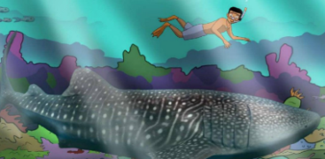
(c) Problem
(What happened in the sea?)
When March arrived, Datiz dived into the water and found his friend Splash. They suddenly heard a loud BOOM, and saw a mess of bubbles, broken coral and dead fish floating to the surface.
(Before the people learned about the bad side of the new fishing method, what did they care about?)  Before the people learned about the bad side of blast fishing, they only cared about the amount of fish caught. | 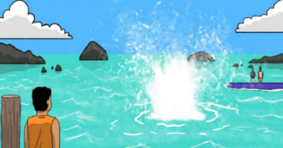
“We, merchants, can sell more fish to chefs!”
“We, chefs, can buy fish cheaply and sell meals at lower prices!”
“We, fishermen, can catch more fish to sell at the market!”
“We, customers, can pay for meals at lower prices!”

“We, merchants, won’t sell fish that are caught with fish bombs! We must tell the fishermen.”
“We, chefs, will not buy fish that are caught using fish bombs because customers want us to cook the sustainably caught fish”.
“We, customers, only want to have fish that are caught in a sustainable way!”
“We, fishermen, feel sad to have no more coral reefs and fish!”

(d) Solution  (What did the character do? What did the people want to do?)  Datiz conducted talks and showed the people pictures of the terrible effects of blast fishing. They wanted to protect the reefs and the fish after learning about its bad side. | 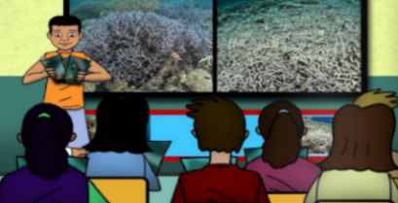

(e) Moral/ Message
1. If we protect our marine life from further damage, they will recover.
2. To protect the environment, it is important to educate all the people.

Datiz and the Whale Shark

Post-reading Stage
- Using linking words to express contrasting ideas
Even though | the chef has plenty of fish for his customers now, | it is not sustainable.
Although | the merchant has many fish to sell at low price now, | soon she will have none.
a different idea:
There will be no more fish in the future.
the original idea:
People only care about the amount of fish caught now / the price of fish sold now.
linking words/ conjunctions

- Underline the sentence with contrasting ideas from the following page:

- It is important to live a green life to reduce waste and protect the environment. Write two sentences to explain to the children why they need to live a green life and how to protect the environment.
e.g. Although it is comfortable to turn on the air-conditioner, it will cause global warming.
- Even though it is convenient to buy plastic bottles of water, you should bring your own water
to reduce waste when you have outdoor activities.
- You should save paper and use both sides of each sheet of paper before throwing it away
though it does not cost much to buy paper.

- Using conditional sentences to express cause-effect relationship
Effect:
Main clause to explain the result
If clause to explain the Cause:

If people continue blast fishing, | soon there will be no more coral reefs and no more fish for people to eat.
If we protect the coral reefs from further damage, | over time they will recover.

- Underline the sentence with cause-effect relationship from the following page:

- Many children want to keep a pet. Write two sentences to give advice to the children who want to keep a pet.
e.g. If you do not think carefully before keeping a pet, it will be a big trouble to you and to your pet.
- If you take good care of your pet, it will be happy and healthy.
- If you patiently train your pet so that it develops good manners and behaviour, it will be your
loyal friend.

- You are a young ambassador. You are concerned about the endangered animals and care for the pets. A reporter is interviewing you about animal protection. Answer the questions.
(Accept any reasonable answers)

- An interview about Endangered Animals
1) | Reporter: Why is it important to protect the endangered animals? | You: If we do not protect the endangered animals, they will be
 |  | extinct one day./ Although there are many species of animals
 |  | in the world, many of them are dying out soon. Therefore, we
 |  | should protect them.
2) | Reporter: How can we protect the endangered animals? | You: If we protect the environment and stop destroying the
 |  | habitats of the endangered animals, their lives can be saved./
 |  | Although the government has set up laws to protect the
 |  | endangered animals, it is necessary to educate the children to
 |  | know more about these animals.
3) | Reporter: What can students do to protect the environment? | You: If we use less plastic, there will be less waste. / Although it
 |  | is good to recycle materials, it is important to save energy and
 |  | reduce waste.

- An interview about Pet Care
1) | Reporter: Why is it good to keep a pet? | You: If you keep a pet, you will have a good companion. /
 |  | Although it is challenging to take care of a pet, you will become
 |  | a kind and caring person when you learn the skills.
2) | Reporter: Can you give some advice to your friends if they want to keep a pet? | You: If you want to keep a pet, you need to learn how to take
 |  | care of it./ Although the pets look cute and lovely, you need
 |  | to think carefully before keeping a pet. It is a lifetime
 |  | commitment.
3) | Reporter: How can we keep a healthy pet dog? | You: If you want to keep a healthy pet dog, you need to exercise
 |  | it and feed it a balanced diet./ Although it is time-consuming to
 |  | bring your pet dog for a walk, it helps keep it healthy.

Pre-writing
A diary entry from the perspective of the whale shark
(Suggested Answers)
- Underline the key words and important information in each paragraph.
Content and Organisation of the Diary
The date is at the top of the diary entry.
Paragraphs 2 & 3:
- How did the people catch fish?
- Why is this fish catching method cruel?
- How does it affect the environment?
Paragraph 4:
- What can people do to help the whale shark and other sea creatures?
Paragraph 1:
- Where can you find the whale shark?
- How does it look like?
- What is its favourite food?
- Underline one example of each feature from the diary entry using different colours.
Grammar Items and Language Used in the Diary Entry
Include your hopes, e.g. I hope Sapi can resume its beauty soon.
Don’t forget to:
- use a friendly tone
- describe the events in the order they happen

Include your feelings and thoughts, e.g. We were so scared!
Use personal pronouns, e.g. I and we.
Use the simple present tense to state the fact, e.g. I am as big as a school bus!
Use the simple past tense to write about things that happened, e.g. I couldn’t wait to see my good human friend, Datiz.
Writing a diary entry
(Suggested Answers)

- Information search

Cruel practices to pet dogs | Reasons
- Chaining dogs to a post all day and night  - Keeping them in cages | - Dogs are social animals who need and deserve companionship, exercise and mental stimulation.  - These practices prevent them from satisfying all their needs and is just a way for guardians to ignore and store their dogs in a place like a warehouse as if they were goods until they get around to taking care of them properly.
- Cruel, unnecessary surgery that is performed on dogs, e.g. ear-cropping, tail-docking, and debarking | - Human convenience or preference  - Painful and traumatic to dogs  - They are banned in many countries, but they remain legal in the U.S.
- Hoarding of animals | - It may cause animal overpopulation crisis.  - The consequences are serious and often fatal for animals.

(Accept any reasonable answers.)

- Ideas for shared writing

Paragraph | Ideas
1 | The weather  - fine  - could see sunshine outside my small cage  Feelings  - unhappy
2 | Things that happened with thoughts and feelings  - In the morning  - Amy forgot to put toys in the cage and clean the potty area  - all alone in the small and dirty cage  - felt depressed  - could not exercise  - had nothing to do  - In the afternoon  - heard someone shouting loudly as if an accident was going to happen  - could not escape  - scary
3 | Reflections  - Thoughts and feelings  - cruel to keep animals alone in cages for long hours  - animals have needs and feelings  - Things that Amy can do for me  - let me stay out of the cage while she is away  - keep another dog to accompany me
(Accept any reasonable answers.)

- Shared writing (sample)

Friday, 7 August 20XX

The weather was fine today. I could see sunshine outside my small cage. However, it was just another unhappy day for me.

As usual, Amy put me in the cage early in the morning. Perhaps, she was busy last night. She only put some water and a little food in the cage but forgot to put toys and clean the potty area. I felt depressed as I was all alone in the small and dirty cage. I could not exercise and had nothing to do. To add to the unlucky events, I heard someone shouting loudly as if an accident was going to happen. However, I could not escape. The experience was really scary!

I think it is very cruel to keep animals alone in cages for long hours because animals have needs and feelings. I hope Amy can let me stay out of the cage while she is away or keep another dog to accompany me.

- Individual writing
(Accept any reasonable answers.)

- Self-assessment checklist
(Accept any reasonable answers.)

- Revise the writing
(Accept any reasonable answers.)

Acknowledgements

- Information and images/pictures in this set of worksheets are taken from the following book published by Word Scientist.org:
Datiz and the Whale Shark by Kelly Case
https://data.booksie.org/word-scientists/datiz-and-the-whale-shark-2.pdf

- Information on the video about whale sharks is taken from the video clip produced by Free School:
All about Whale Sharks for Children: Whale Shark Video for Kids
https://www.youtube.com/watch?v=jApMS38YR6w

- Information on the video about blast fishing is taken from the video clip produced by robbielab:
Blast Fishing Aftermath
https://www.youtube.com/watch?v=aFWK-MSg3fo

- Information on the website of People for the Ethical Treatment of Animals (PETA) is adopted in the information search activity to prepare students for the writing task:
Animal Right Issues – Companion Animals – Cruel Practices
https://www.peta.org/issues/animal-companion-issues/cruel-practices/

- The website of the Society for the Prevention of Cruelty to Animals (SPCA) Hong Kong is introduced in the part on individual writing. Students are encouraged to search for information on the website to understand the cruelty animals are facing and reflect on what animals would like us to do for them.
What is Animal Welfare?
https://www.spca.org.hk/en/animal-welfare/what-is-animal-welfare

